# Style and Colour

## Style

You can set particular style with .set_style() method. You can pass any of the values -white, dark, whitegrid, darkgrid, ticks and you will get required style.

import seaborn as sns  
import matplotlib.pyplot as plt  
tips = sns.load_dataset('tips')  
sns.set_style('whitegrid')  
sns.countplot(x='sex',data=tips)  
plt.show()

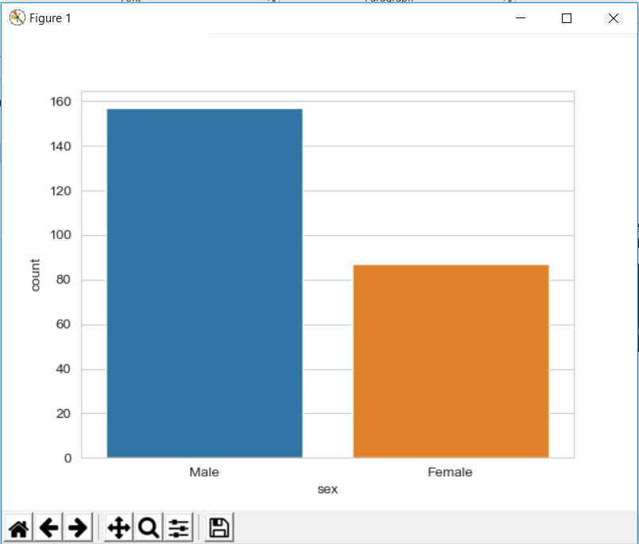

## Spine Removal

import seaborn as sns  
import matplotlib.pyplot as plt  
tips = sns.load_dataset('tips')  
sns.countplot(x='sex',data=tips)  
sns.despine()  
plt.show()

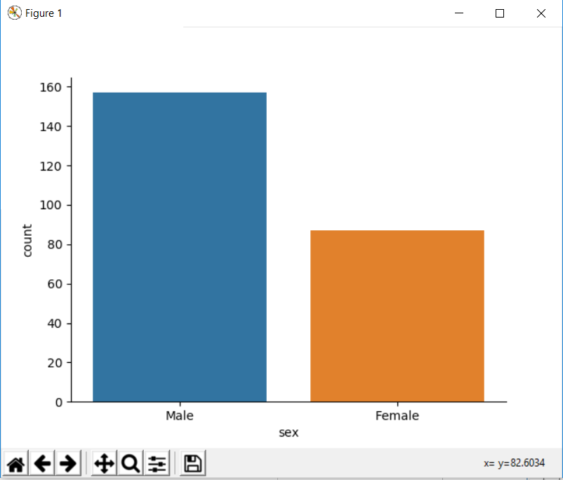

We can also remove spines from left and bottom by specifying as left=True

import seaborn as sns  
import matplotlib.pyplot as plt  
tips = sns.load_dataset('tips')  
sns.countplot(x='sex',data=tips)  
sns.despine(left=True)  
plt.show()

## Size and Aspect

You can use matplotlib's *plt.figure(figsize=(width,height) * to change the size of most seaborn plots.

You can control the size and aspect ratio of most seaborn grid plots by passing in parameters: size, and aspect.

import seaborn as sns  
import matplotlib.pyplot as plt  
tips = sns.load_dataset('tips')  
plt.figure(figsize=(12,3))  
sns.countplot(x='sex',data=tips)  
plt.show()

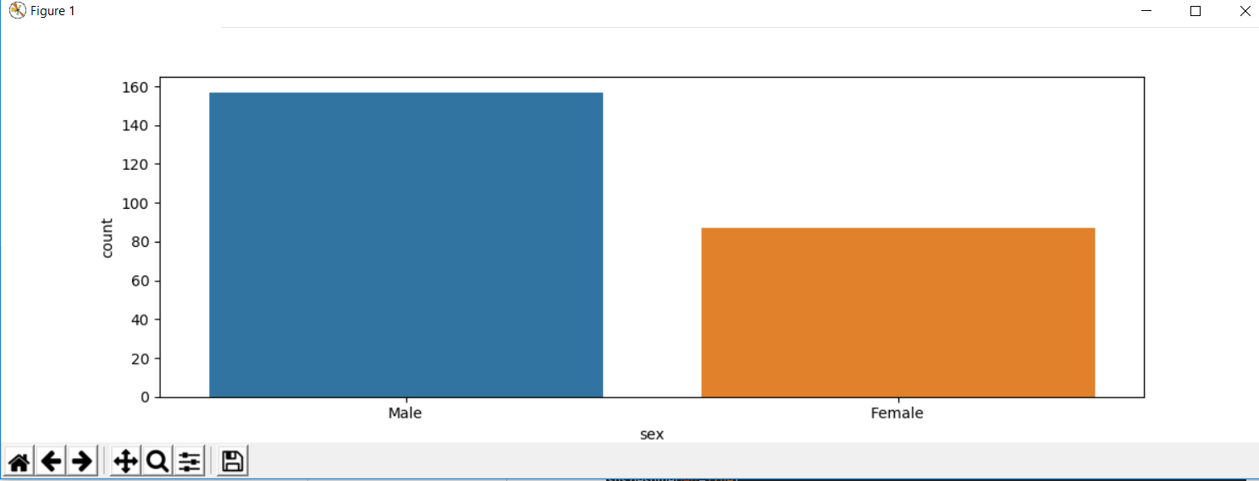

You can also pass in the aspect in the plot call as below

**sns.lmplot(x='total_bill',y='tip',size=2,aspect=4,data=tips)**

## Scale and Context

The set_context() allows you to override default parameters.

import seaborn as sns  
import matplotlib.pyplot as plt  
tips = sns.load_dataset('tips')  
sns.set_context(context="poster",font_scale=2)  
sns.countplot(x='sex',data=tips)  
plt.show()

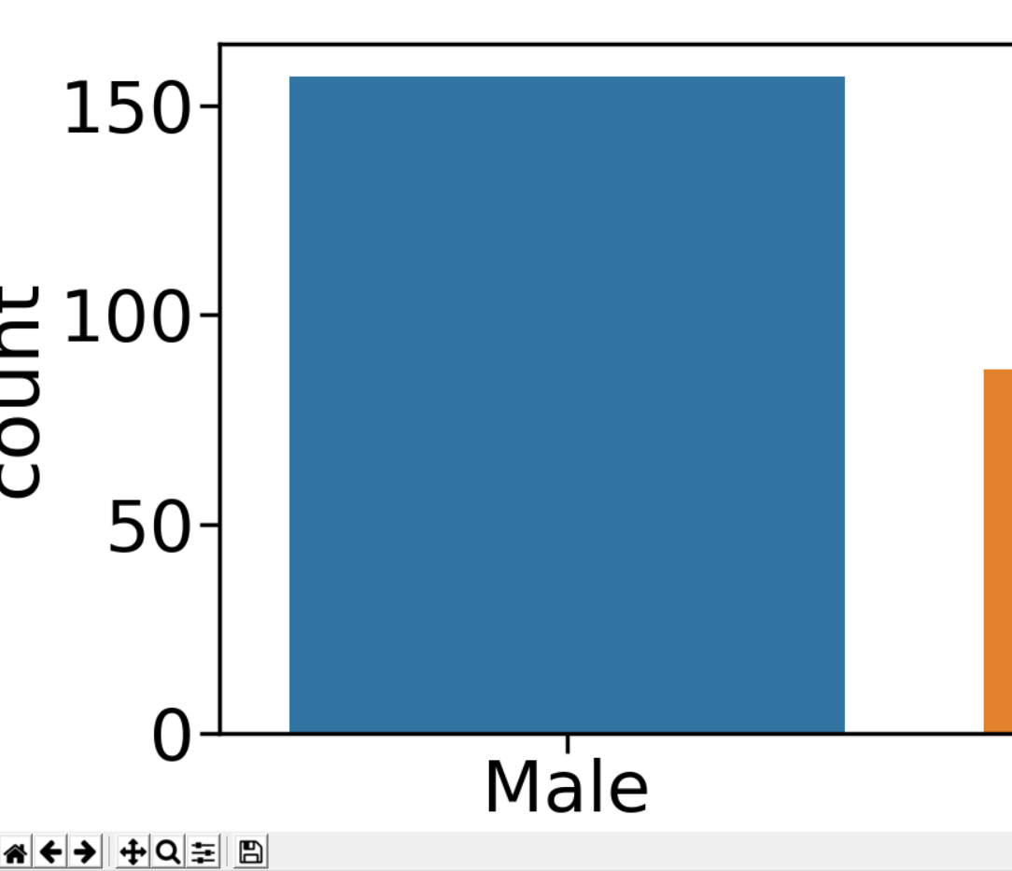

## Palettes and Colours

You can specify palette=”” argument for different colour schemes available. The list of values for palette can be seen from the documentation of matlplotlib colormap.